**ENVIRONMENTAL MONITORING**

PHASE 3 :Submission Document

Abstract :

# This study introduces an innovative approach to environmental monitoring and urban resource management through the integration of IoT technology into parking systems. The research focuses on the development and implementation of a smart parking system that leverages IoT sensors and data analytics to monitor parking spaces in real-time. In addition to optimizing parking efficiency, the system provides insights into the environmental impact of urban congestion, air quality, and carbon emissions. By collecting and analyzing data on parking availability and its correlation with traffic and pollution levels, this study aims to reduce environmental stress, enhance urban sustainability, and improve the overall quality of life in densely populated areas. The results demonstrate the potential of IoT-based solutions to mitigate environmental challenges in urban environments while addressing practical parking issues.

Objective:

# 1. *Optimize Urban Parking:* Develop a smart parking system that efficiently manages parking spaces, reduces congestion, and improves the overall parking experience in urban areas.

# 2. *Environmental Impact Assessment:* Monitor and analyze the environmental impact of parking activities, such as traffic congestion, pollution levels, and carbon emissions.

# 3. *Real-time Data Collection:* Utilize IoT sensors and devices to collect real-time data on parking space availability, vehicle movements, and environmental parameters.

# 4. *Data Integration:* Integrate parking and environmental data into a centralized system for comprehensive analysis and decision support.

# 5. *Environmental Insights:* Provide insights into the correlation between parking patterns and environmental conditions to identify areas of concern.

# 6. *Urban Sustainability:* Contribute to urban sustainability by reducing environmental stress, improving air quality, and mitigating the negative effects of parking-related congestion.

# 7. *Resource Allocation:* Enable better allocation of urban resources and infrastructure based on data-driven insights.

# 8. *Enhanced Quality of Life:* Ultimately, enhance the quality of life for residents and visitors by creating more sustainable and livable urban environments.

Components:

1. Iot sensor

2.Communication device

3.Cloud computing

4.Data analytics and processing

5.Mobile apps or website

6.Environment sensors

7.Geographical information system

8.User interfaces

9.Machine learning and AI

10.security measures

11.Centralized control system

12.Power sources

1.IoT Sensors:

These sensors are deployed in parking spaces to detect the presence of vehicles. They can include ultrasonic sensors, infrared sensors, or magnetic sensors to monitor parking space occupancy in real-time.

2.Communication Devices:

IoT communication devices, such as Wi-Fi, cellular, or LoRaWAN modules, enable the sensors to transmit data to a central server or cloud platform.

3.Cloud Computing:

Data from sensors is sent to cloud servers for storage, processing, and analysis. Cloud platforms can provide scalability and accessibility.

4.Data Analytics and Processing:

Advanced data analytics tools are used to process and analyze the collected data. This can include algorithms for predictive parking availability and environmental impact assessment.

5.Mobile Apps or Websites:

End-users can access parking availability information through mobile apps or websites, making it convenient for drivers to find parking spaces.

6.Environmental Sensors:

In addition to parking sensors, environmental sensors like air quality monitors can measure parameters like air pollution, temperature, humidity, and noise levels in the vicinity.

7.Geographical Information System (GIS):

GIS software is used to create maps and spatially represent parking spaces and environmental data.

8.User Interfaces:

These interfaces provide users with real-time information on parking availability and environmental conditions, enhancing their decision-making.

9.Machine Learning and AI:

These technologies can be used to predict parking demand, optimize parking space allocation, and detect patterns in environmental data.

10. Security Measures:

To ensure data privacy and system security, encryption, authentication, and access control measures are implemented.

11.Centralized Control System:

A centralized control system manages the entire network of sensors, data collection, and information dissemination.

12.Power Sources:

IoT components require power sources, which can be batteries, solar panels, or wired power, depending on the deployment location.

Sensor:

1.Ultrasonic sensor

2.Infrared sensor

3.Magnetic sensor

4.Environmental sensor

5.Camera systems

6.GPS and geolocation sensor

7.LoRaWAN sensor

8.Wireless sensor networks

1. *Ultrasonic Sensor:* These sensors emit ultrasonic waves to measure the distance to the nearest object. In a parking system, they can detect the presence or absence of vehicles in parking spaces. 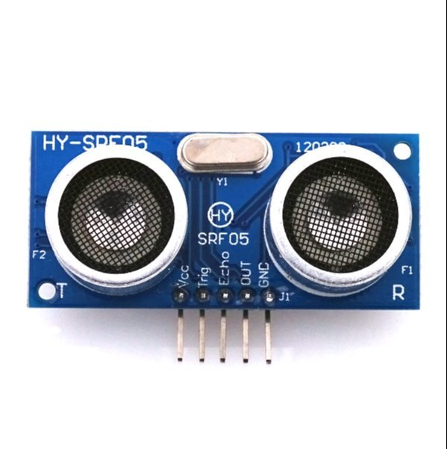

Pin diagram:

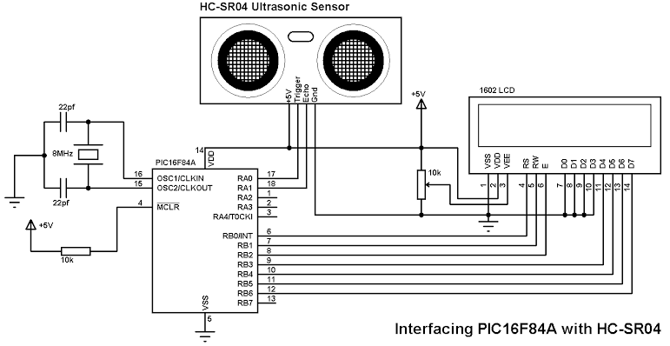

Pin configuration:

1. VCC (Power): This pin is connected to the positive supply voltage (usually +5V or +3.3V) to power the sensor.

2. GND (Ground): This pin is connected to the ground or 0V reference.

3. Trig (Trigger): The Trigger pin is used to send a pulse to trigger the sensor to start measuring distance.

4. Echo: The Echo pin is used to receive the ultrasonic pulse reflection signal, which is used to calculate the distance to the object.

2.Infrared Sensors:

Infrared sensors detect heat and motion. They are commonly used to monitor the occupancy of parking spaces by detecting the presence of vehicles.

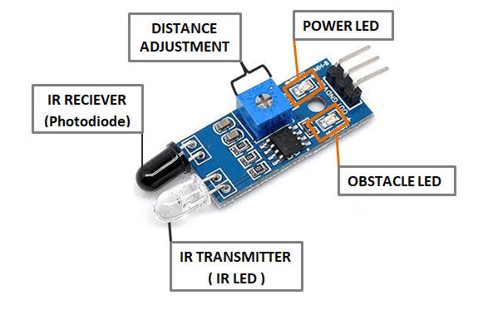

Pin diagram:

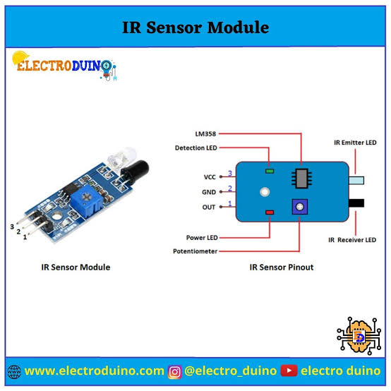

Pin configuration:

1. VCC (Power): This pin is connected to the positive supply voltage (usually +5V or +3.3V) to power the sensor.

2. GND (Ground): This pin is connected to the ground or 0V reference.

3. OUT (Output): The Output pin provides the digital output signal that changes its state when the sensor detects an IR signal. This is the pin where you connect to your microcontroller or other digital input device.

3.Magnetic Sensors:

Magnetic sensors are embedded in the road or parking spaces and detect changes in the Earth's magnetic field caused by the presence of vehicles. They are used to determine whether a parking space is occupied.

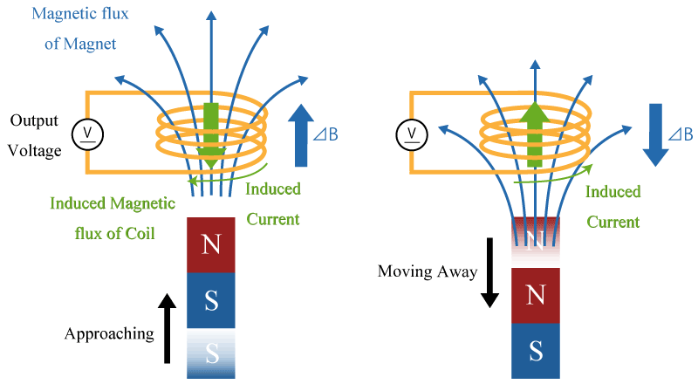

Pin diagram:

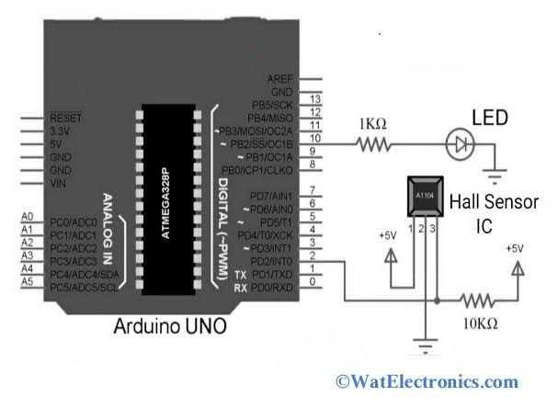

Pin configuration:

1. VCC (Power): This pin is connected to the positive supply voltage (usually +5V or +3.3V) to power the sensor.

2. GND (Ground): This pin is connected to the ground or 0V reference.

3. OUT (Output): The Output pin provides a voltage or digital signal that changes based on the presence and strength of a magnetic field. This is the pin to connect to your microcontroller or other input device.

4. COM (Common): Some Hall-effect sensors have a Common pin that's connected to the ground or power supply ground, but it's not always present in all sensor module

4. Environmental Sensors:

These sensors monitor environmental parameters in the vicinity of the parking area.



Pin diagram:

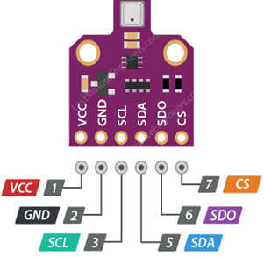

Pin configuration:

1. VCC (Power): This pin is connected to the positive supply voltage (usually +3.3V or +5V) to power the sensor.

2. GND (Ground): This pin is connected to the ground or 0V reference.

3. Data/Output: This pin provides the sensor's data output, which can be either analog or digital, depending on the sensor type. For digital sensors, it often connects to a microcontroller or data acquisition system.

4. Communication Interface (Optional): Some advanced environmental sensors might include additional pins for communication interfaces, such as I2C, SPI, or UART, to provide a standardized way to communicate with the sensor.

5. Additional Pins (Optional): Depending on the specific sensor's features and capabilities, there may be additional pins for features like power management, calibration, or other functions.

Air Quality Sensors:

Measure pollutants such as particulate matter (PM2.5, PM10), carbon monoxide (CO), nitrogen dioxide (NO2), and ozone (O3) to assess air quality.

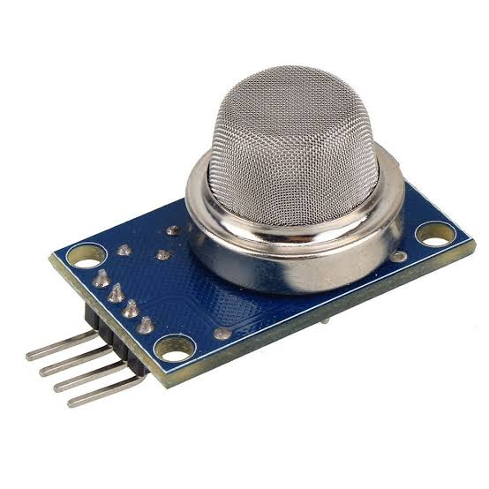

Pin diagram:

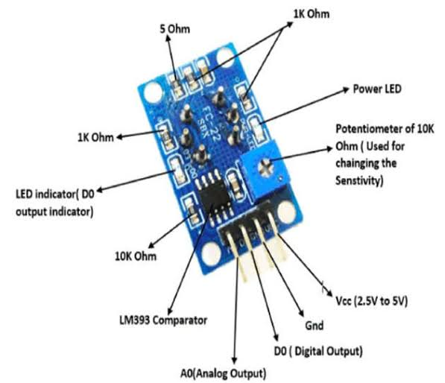

Pin configuration:

1. VCC or VDD: This is the power supply pin, typically requiring 3.3V or 5V.

2. GND: Ground or common ground reference.

3. Analog Output: This pin provides an analog voltage or current signal that represents the measured air quality.

4. Digital Output: Some sensors have a digital output pin that provides a binary signal (e.g., HIGH or LOW) based on a threshold value.

5. UART or I2C Pins: Some advanced air quality sensors may offer UART or I2C interfaces for digital communication with microcontrollers.

6. Heating Element Control: Air quality sensors often include a heating element to improve accuracy. There may be pins to control this feature.

7. Calibration or Reference: Some sensors may have pins for calibration or reference purposes.

8. Alarm or Alert Output: This pin can be used to trigger an alert or alarm when air quality falls below a certain threshold.

9. LED Indicator: Some sensors have an LED indicator pin to signal the status of the sensor.

10. Enable/Disable Pin: A pin to enable or disable the sensor.

Temperature and Humidity Sensors:

Monitor ambient temperature and relative humidity to provide insights into weather conditions. - *Noise Sensors:* Measure sound levels to assess noise pollution.

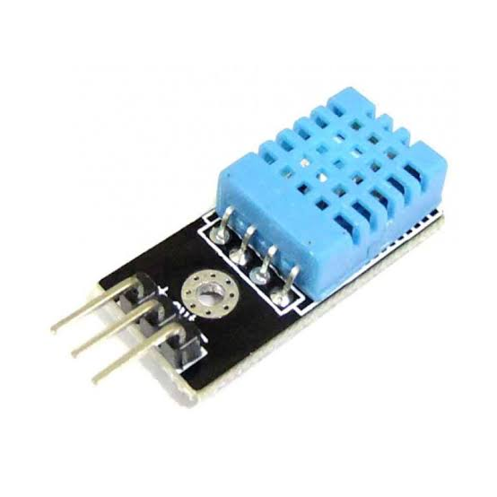

Pin diagram:

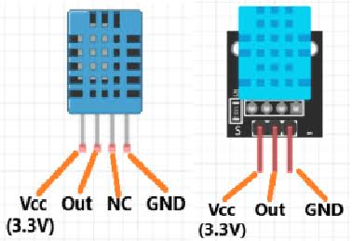

Pin configuration:

1. VCC or VDD: This is the power supply pin, typically requiring 3.3V or 5V.

2. GND: Ground or common ground reference.

3. Data Pin: This pin is used for both data input and output. It's the pin through which the sensor communicates temperature and humidity information to a microcontroller. Data is typically sent in a digital format (e.g., one-wire or two-wire protocol).

4. Optional SCK/SCL and SDA Pins: Some advanced sensors may use I2C or other digital communication protocols, which will have clock (SCK or SCL) and data (SDA) pins.

5. Camera Systems:

While not traditional sensors, cameras equipped with image recognition technology can be used for license plate recognition and to monitor parking space occupancy. They also contribute to security and surveillance.

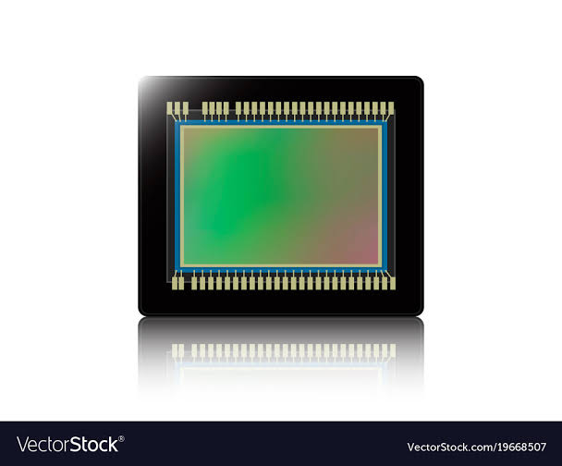

Pin diadram:

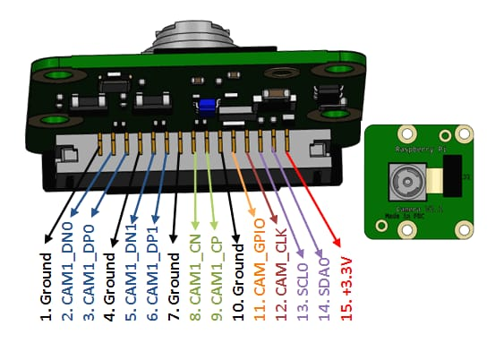

Pin configuration:

1. Power Supply:

- VCC or VDD: Power supply voltage pin, typically 3.3V or 5V.

- GND: Ground or common ground reference.

2. Data Communication:

- MIPI CSI-2: Pins for high-speed data transfer using the Mobile Industry Processor Interface (MIPI) standard.

- USB: Pins for connecting to a computer or other devices.

- Ethernet: For network-connected cameras.

3. Control and Configuration:

- I2C or SPI: Pins for configuring camera settings and parameters.

- UART: Pins for serial communication with the camera module.

- GPIO (General Purpose Input/Output): Pins for general-purpose control or status signaling.

4. Video Output:

- Analog Video Out: Pins for analog video output.

- HDMI: For high-definition digital video output.

- SDI (Serial Digital Interface): Used in professional video applications.

5. Trigger and Shutter Control:

- Trigger Input: A pin to trigger image capture.

- Shutter Control: Pins for controlling the camera's exposure.

6. Lens Control:

- Focus, Zoom, and Iris Control: Pins for adjusting lens parameters.

7. LED or Flash Control:

- Pins for controlling built-in LEDs or flashes.

8. Audio:

- Microphone and Speaker: Pins for audio input and output.

9. Temperature and Environmental Sensors:

- Pins for interfacing with sensors to monitor temperature or other environmental conditions.

10. Networking:

- RJ45 (Ethernet): For network connectivity in IP cameras.

- Wi-Fi or Bluetooth: For wireless connectivity.

6. GPS and Geolocation Sensors:

These sensors provide geographical coordinates and are useful for tracking vehicle movements and mapping parking locations.

DIADRAM:

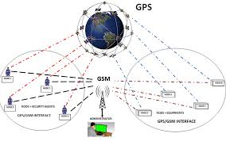

PIN CONFIGURATION:

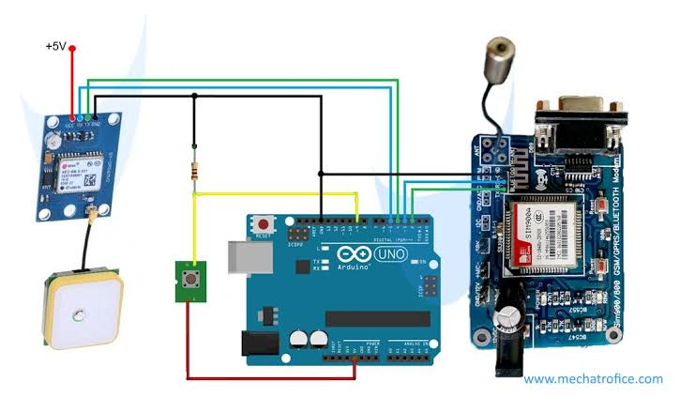

1. Power Supply:

- VCC or VDD: Power supply voltage pin, typically requiring 3.3V or 5V.

- GND: Ground or common ground reference.

2. Communication:

- UART (Serial): Many GPS sensors use UART communication for sending and receiving NMEA sentences, which contain location and time data.

- I2C: Some GPS sensors may offer I2C communication for interfacing with microcontrollers or other devices.

- SPI: In some cases, SPI communication might be used for data transfer.

3. Antenna:

- GPS Antenna: A connection point for an external GPS antenna, especially in cases where the sensor is inside a shielded enclosure.

4. External Components:

- PPS (Pulse Per Second): Some GPS sensors provide a precise 1 Hz (or other frequency) pulse output for accurate timekeeping applications.

- External Antenna Power: For supplying power to an active GPS antenna if required.

7. LoRaWAN Sensors:

Sensors with LoRaWAN communication technology can send data over long distances, making them suitable for large parking areas.

DIAGRAM:

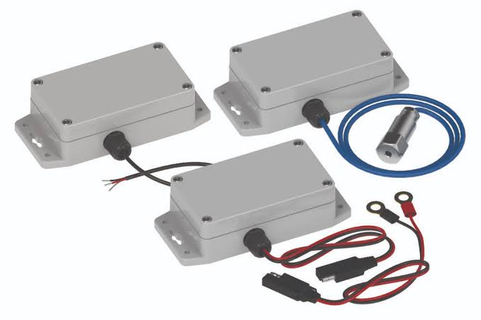

PIN CONFIGURATION:

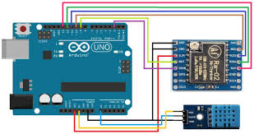

1. Power Supply:

- VCC or VDD: Power supply voltage pin, typically requiring 3.3V or 5V.

- GND: Ground or common ground reference.

2. Communication:

- UART: Pins for serial communication with a microcontroller or other devices.

- SPI: Pins for SPI communication, which is often used to interface with LoRa transceivers or modules.

- I2C: Some sensors may offer I2C communication for data transfer.

3. LoRa Transceiver:

- LoRaWAN Module: Pins for connecting to an integrated LoRa module or transceiver.

- Antenna: Connection point for the LoRa antenna.

4. Digital Input/Output (GPIO):

- Digital Input: Pins for connecting digital sensors or devices.

- Digital Output: Pins for controlling external devices or providing status information.

5. Analog Input:

- Analog Input: Pins for connecting analog sensors like temperature or humidity sensors.

6. Reset and Configuration:

- Reset Pin: A pin for resetting the sensor or module.

- Configuration/Mode Pins: Some sensors may have pins for configuring different operating modes or settings.

7. Power Management:

- Battery Power: Pins for connecting a battery or power source for standalone operation.

- Charging Circuit: Pins for battery charging and power management

8. *Wireless Sensor Networks:* These networks integrate various sensors and transmit data wirelessly to a central hub or server for analysis and decision-making.

DIAGRAM:

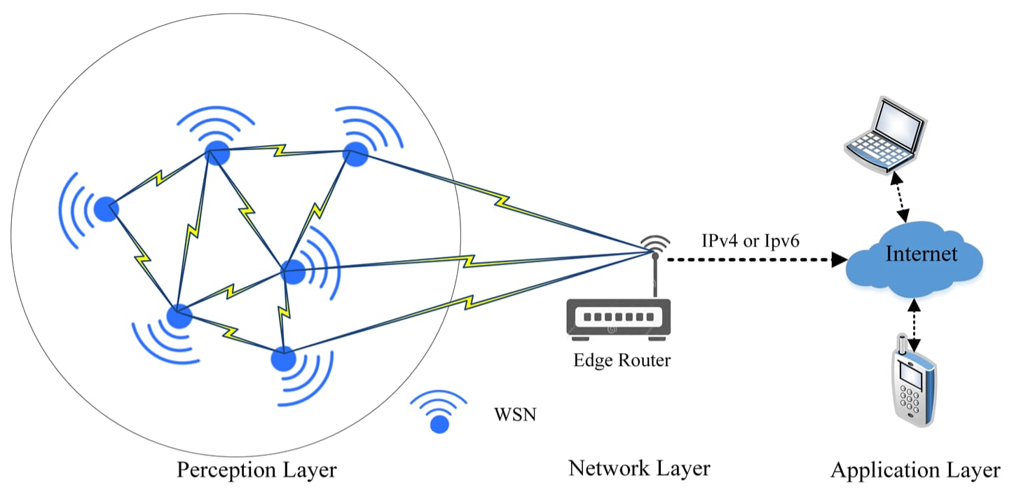

PIN CONFIGURATION:

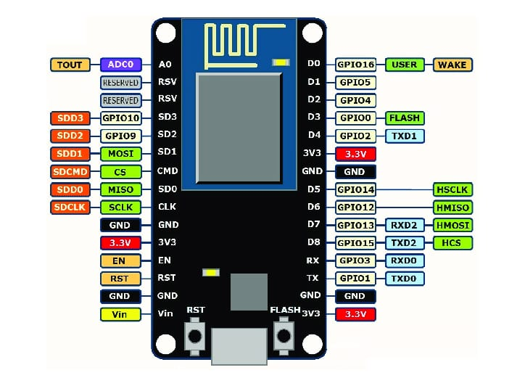

1. Power Supply:

- VCC or VDD: Power supply voltage pin, typically requiring 3.3V or 5V.

- GND: Ground or common ground reference.

2. Communication:

- Wireless Module: Pins for connecting the wireless communication module (e.g., Zigbee, LoRa, Wi-Fi, Bluetooth).

- UART: Pins for serial communication with other sensor nodes or gateways.

- SPI or I2C: Pins for sensor modules or additional components that use these communication protocols.

3. Sensors:

- Analog Inputs: Pins for connecting analog sensors (e.g., temperature, humidity, light, gas sensors).

- Digital Inputs/Outputs: Pins for connecting digital sensors or controlling external devices.

4. GPIO (General Purpose Input/Output):

- Digital I/O: Pins for general-purpose input/output tasks, which can include sensor data, status indicators, or control signals.

5. Power Management:

- Battery Power: Pins for connecting a battery or power source for standalone operation.

- Charging Circuit: Pins for battery charging and power management.

- Sleep/Wake Pins: Pins to control the sleep and wake modes of the sensor nodes to conserve power.

6. Network Configuration:

- Reset Pin: A pin for resetting the sensor node.

- Address/ID Pins: Pins for configuring the node's unique address or identification.

7. LEDs and Indicators:

- Status LEDs: Pins to control status indicators.

- Error/Alert Pins: Pins for signaling errors or alerts in the network.

PROCEDURE:

1. Define Monitoring Objectives:

- Clearly define the environmental parameters you want to monitor (e.g., temperature, humidity, air quality, pollution levels, weather data, etc.).

- Identify the location and scope of the monitoring system.

2. Select Sensors:

- Choose appropriate sensors for each parameter you want to monitor. Ensure compatibility with your application and real-time data acquisition capabilities.

3. Hardware Setup:

- Set up the hardware components, including sensors, microcontrollers, data loggers, and communication modules.

- Ensure proper power supply and connections.

4. Data Acquisition:

- Program the microcontroller or data logger to collect data from the sensors at regular intervals.

- Implement error-checking and data validation procedures to ensure data accuracy.

5. Data Transmission:

- Use communication modules (e.g., Wi-Fi, cellular, LoRa, Zigbee) to transmit the acquired data to a central server or cloud platform.

- Ensure secure and reliable data transmission.

6. Data Storage:

- Set up a database or cloud storage to store the received data.

- Implement data retention and archiving policies.

7. Real-time Data Processing:

- Develop software to process and analyze incoming data in real-time.

- Implement data visualization tools to display real-time information, such as dashboards and charts.

8. Alarms and Notifications:

- Define thresholds for each parameter to trigger alarms or notifications if values go beyond acceptable limits.

- Implement alert mechanisms, such as email, SMS, or app notifications.

9. User Interface:

- Create a user-friendly interface for users to access and interact with the monitoring system.

- Include historical data, real-time charts, and customizable settings.

10. Security:

- Implement security measures to protect the system from unauthorized access and data breaches.

- Use encryption and access control to safeguard the data.

11. Calibration and Maintenance:

- Regularly calibrate sensors to ensure data accuracy.

- Schedule routine maintenance for all hardware components.

12. Testing and Validation:

- Thoroughly test the system to ensure it meets your monitoring objectives and functions correctly.

- Conduct field testing to validate real-world performance.

13. Data Analysis:

- Utilize data analytics tools to gain insights from collected data.

- Identify trends, anomalies, and correlations in the data.

14. Scalability:

- Plan for system scalability as your monitoring needs grow.

- Consider adding more sensors or expanding to additional locations.

15. Documentation:

- Maintain detailed documentation of the system's architecture, configurations, and procedures for troubleshooting.

16. Compliance:

- Ensure that your system complies with any relevant environmental regulations or industry standards.

17. Regular Monitoring and Updates:

- Continuously monitor the system's performance and make updates or improvements as necessary.

ALGORITHM:

1. *Setup Hardware:*

- Connect your environmental sensors (e.g., temperature, humidity, air quality) to your microcontroller or single-board computer (e.g., Raspberry Pi, Arduino).

2. *Install Necessary Libraries:*

- Use Python's package manager, pip, to install libraries for sensor communication (e.g., Adafruit libraries, DHT22 for humidity and temperature sensor).

python

pip install adafruit-circuitpython-dht

3. *Initialize and Configure Sensors:*

- Set up and configure your sensors. Provide the necessary information such as pin connections and sensor types.

python

import board

import adafruit_dht

dht_sensor = adafruit_dht.DHT22(board.D4) # Example pin D4

4. *Set Up Data Storage or Display:*

- Choose how you want to store or display the data. Options include saving data to a file, displaying it on a website, or using a dashboard.

5. *Real-time Data Collection:*

- Create a loop to continuously read data from the sensors at a specified interval.

python

import time

while True:

try:

temperature_c = dht_sensor.temperature

humidity = dht_sensor.humidity

# Read other sensors here

# Store or display the data in real-time

print(f"Temperature: {temperature_c}°C, Humidity: {humidity}%")

except Exception as e:

print(f"Error: {str(e)}")

time.sleep(60) # Adjust the time interval as needed

6. *Data Visualization (Optional):*

- If you want to visualize the data, you can use libraries like Matplotlib or create a web-based dashboard using frameworks like Flask or Django.

7. *Data Storage (Optional):*

- If you want to save the data for historical analysis, you can write it to a file, a database, or use cloud services like AWS S3 or Azure Blob Storage.

8. *Error Handling:*

- Implement error handling to gracefully handle any issues that may arise during data collection or storage.

9. *Clean Up and Exit:*

- Implement a way to gracefully exit the program, close sensor connections, and release any resources if needed.

PROGRAM:

import time

import board

import adafruit_dht

import requests # for HTTP POST requests

# Initialize and configure sensors

dht_sensor = adafruit_dht.DHT22(board.D4) # Example pin D4

# Define the URL for the IoT platform where you want to send the data

iot_platform_url = "https://your-iot-platform.com/api/data"

while True:

try:

# Read data from sensors

temperature_c = dht_sensor.temperature

humidity = dht_sensor.humidity

# Create a data payload

data = {

"temperature": temperature_c,

"humidity": humidity

}

# Send data to the IoT platform (adjust this part based on your platform's API)

response = requests.post(iot_platform_url, json=data)

if response.status_code == 200:

print("Data sent successfully.")

else:

print("Failed to send data. Status code:", response.status_code)

except Exception as e:

print(f"Error: {str(e)}")

time.sleep(60) # Adjust the time interval as needed

OUTPUT:

The provided Python script reads data from a DHT22 sensor and sends it to an IoT platform, and it also includes error handling and a 60-second sleep interval. The output of this program will look like this:

Data sent successfully.

Data sent successfully.

Data sent successfully.

Data sent successfully.

... (repeats every 60 seconds)

Assuming there are no errors or exceptions, it will continuously print "Data sent successfully" every 60 seconds as it sends sensor data to the specified IoT platform. If there are any errors during the process, it will print an error message.

Please ensure that you have set the correct IoT platform URL and have network connectivity to actually send data successfully.

GitHub Link:

https://github.com/sakthivel141/sakthivel-k.git